**Buddhist Holidays**

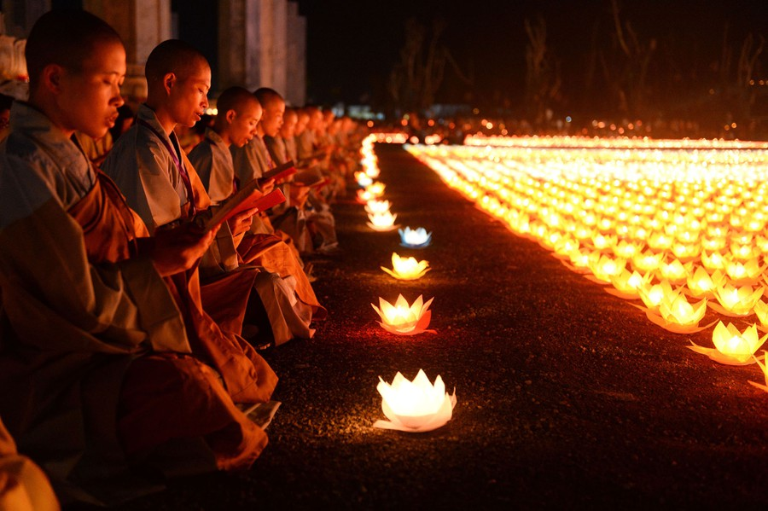Every year, Buddhists celebrate Vesak, a festival that commemorates Buddha’s birth, enlightenment and death.-During each quarter of the moon, followers of Buddhism participate in a ceremony called Uposatha. This observance allows Buddhists to renew their commitment to their teachings.-They also celebrate the Buddhist New Year and participate in several other yearly festivals.